Online Medication & Prescription Tracker

1.Project Statement
Managing medication schedules, doctor prescriptions, and pharmacy stock can be challenging, especially for patients with chronic illnesses or multiple prescriptions.
This project aims to provide a centralized system where doctors, patients, and pharmacists can coordinate effectively.
It automates prescription tracking, medicine reminders, and stock management — ensuring patients never miss a dose and pharmacies always maintain proper inventory.
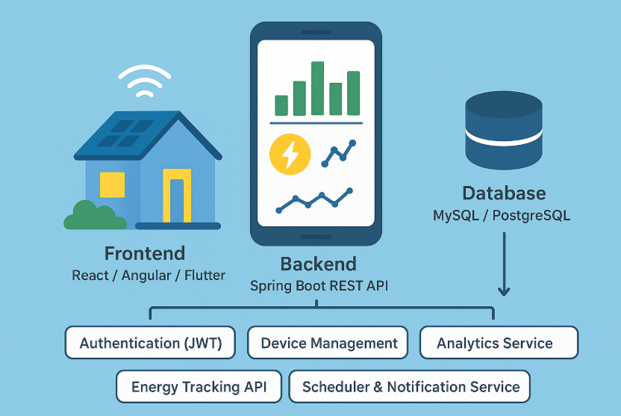

2.Outcomes
- User Roles: Patient, Doctor, Pharmacist, Admin
- Prescription uploads and doctor validation
- Medicine reminders and dosage tracking
- Drug inventory management and stock alerts
- Analytics dashboard for doctors and pharmacists
- API integration for drug details and interactions

3.Modules to be Implemented

Authentication & Role Management
- Secure JWT-based login and registration.
- Role-based permissions for Patients, Doctors, Pharmacists, and Admin.
- Profile setup with personal, medical, or business details.

Prescription Management
- Doctors can issue and upload digital prescriptions.
- Patients can view approved prescriptions and download them as PDFs.
- Track prescription validity, renewal dates, and doctor’s notes.

Medication Tracker
- Patients can log medicines and receive reminders for dosage times.
- Automatic scheduling for daily, weekly, or custom reminders.
- Alert system for missed or delayed doses.

Pharmacy Inventory Management
- Pharmacists can add, update, and track drug stock levels.
- Automated low-stock alerts for restocking.
- Drug information fetched via a medicine API (e.g., RxNorm or OpenFDA).

Analytics & Reporting
- Doctor dashboard showing patient adherence and prescription stats.
- Pharmacy analytics for sales, stock movement, and expiry tracking.
- Patient reports showing dosage compliance and medicine history.

4.Week-Wise Milestones

Milestone 1: Weeks 1–2
Authentication & Role Setup
Implement JWT-based authentication:
- Build secure endpoints for registration and login with JWT token validation.
- Encrypt passwords and ensure token-based session management.
Role-based access control:
- Patients can manage prescriptions and reminders.
- Doctors approve and issue prescriptions.
- Pharmacists handle stock. Admin oversees all roles.
Profile setup:
- Collect user-specific data (e.g., medical history for patients, license number for doctors, shop details for pharmacists).
- Store profile details for personalization and role validation.

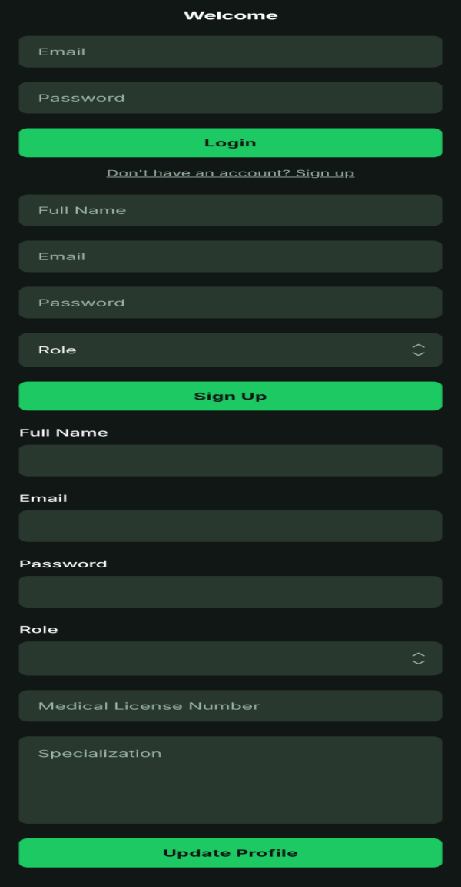

Milestone 2: Weeks 3–4
Prescription Management Module
Prescription upload and approval:
- Doctors can issue prescriptions via a form or upload PDF documents.
- Patients receive notification once a prescription is validated.
Prescription lifecycle management:
- Include fields such as medication name, dosage, duration, and instructions.
- Track expiration and renewal periods for long-term medications.
Audit and version control:
- Maintain history of prescription changes for compliance.
- Allow doctors to update or renew prescriptions when required.
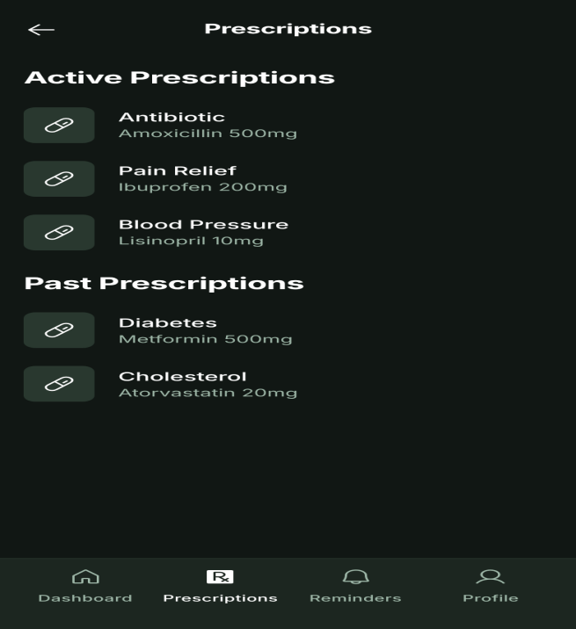

Milestone 3: Week 5
Medication Tracker & Reminder System
Medication schedule creation:
- Patients can log their medicines and create reminder schedules.
- Include options for daily, alternate day, or custom timing.
Notification system:
- Send email or push reminders for each dosage.
- Allow snooze or mark-as-taken actions from the patient dashboard.
Missed dose analytics:
- Track adherence percentage for each patient.
- Generate automatic alerts for doctors if adherence falls below threshold.
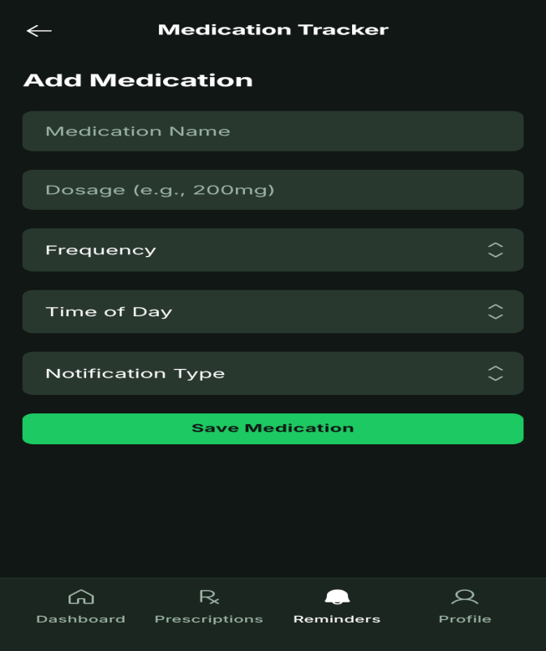

Milestone 4: Weeks 6–7
Pharmacy Inventory Management
Drug inventory CRUD operations:
- Pharmacists can add, edit, delete, and view medicines in stock.
- Each entry includes name, batch number, expiry date, and stock quantity.
Stock alerts:
- Automatically notify pharmacists when stock drops below a set threshold.
- Mark expired medicines and recommend disposal or replacement.
Drug details API integration:
- Integrate external API to fetch drug information (e.g., composition, interactions).
- Display full drug details for patients and pharmacists for safety checks.
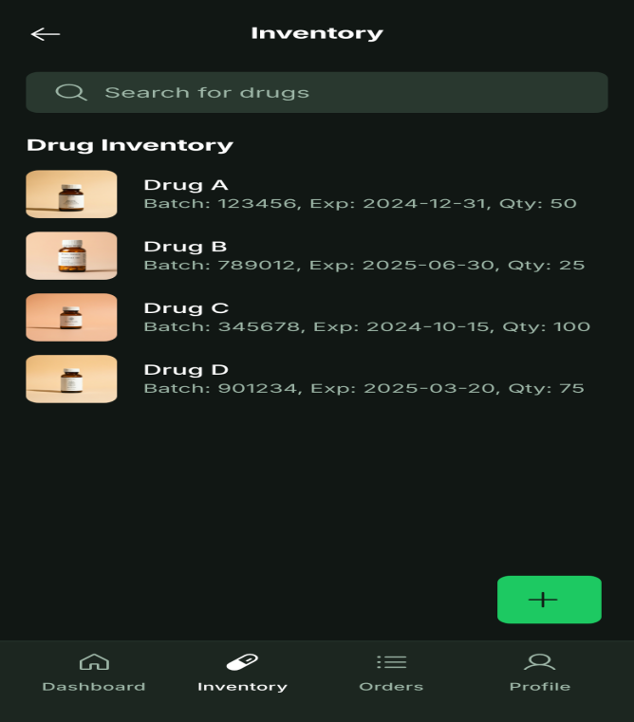

Milestone 5: Week 8

Analytics & Reporting
Dashboard visualization:
- Graphs for patients showing adherence trends over time.
- Doctor analytics for patient prescriptions issued and adherence levels.
Pharmacy insights:
- Reports showing top-selling drugs and upcoming expirations.
- Sales vs. stock visualization for inventory optimization.
Overall system analytics:
- Admin can monitor total users, prescriptions, and alert logs.
- Generate downloadable reports for compliance and audits.
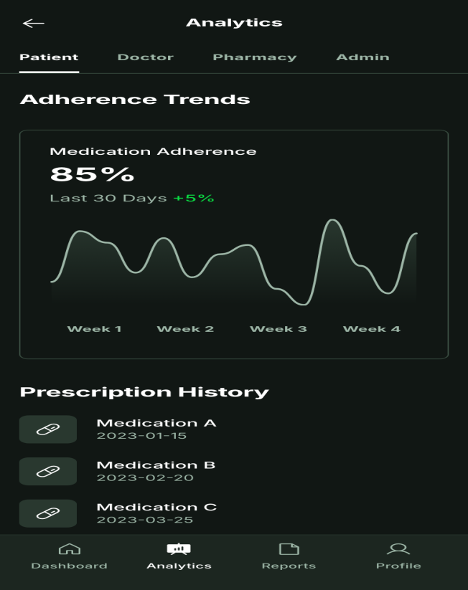

5.Evaluation Criteria
• Week 1: Project setup, environment configuration, and database schema design.
• Week 2: Authentication and role-based setup complete.
• Week 3: Prescription management module development started (upload, view, basic CRUD).
• Week 4: Prescription management functional (approval workflow, PDF download, version control).
• Week 5: Reminder and medication tracking system operational.
• Week 6: Pharmacy inventory module development (CRUD operations, stock alerts).
• Week 7: Pharmacy module integrated with API (drug details and interactions).
• Week 8: Analytics dashboard finalized and tested (patient adherence, doctor & pharmacy reports, admin insights).

6. Workflow diagram:

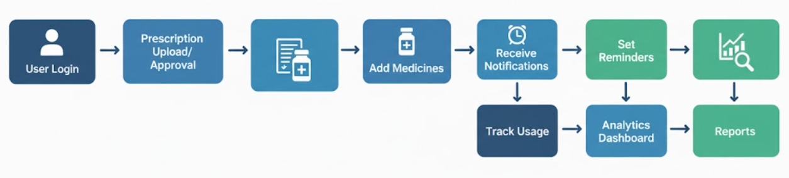

Architecture diagram:

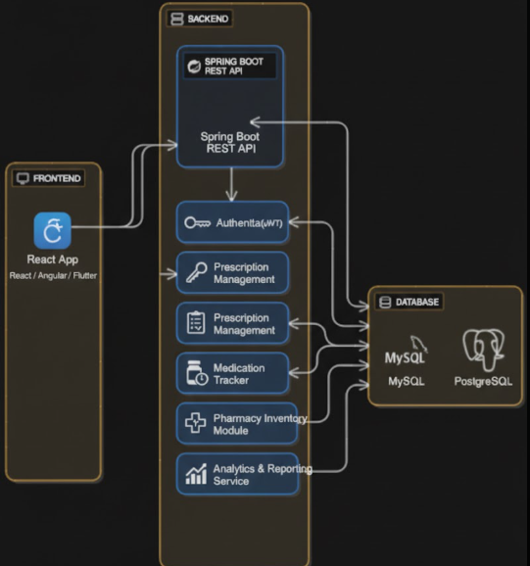

8.Schema diagram:
